**#BreakupWithHarmattan – Nivea’s Harmattan Season Skin Care Campaign**

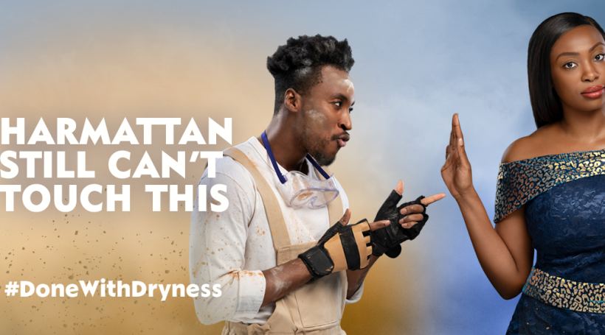

The harmattan season which usually occurs towards the end of the year and dovetailing to the first quarter of the new year in Nigeria and some other parts of the world is characterized by dry winds and dusty atmosphere. A typical feature of this weather is dry skin and sometimes white patches and cracked lips. It was this mix that was at the center of Nivea’s #BreakupWithHarmattan campaign.

Towards the last quarter of the year 2020, [Nivea](https://en.wikipedia.org/wiki/Nivea) launched the #BreakupWithHarmattan campaign in Nigeria after earlier running it in Ghana. The campaign ran under other similar copies as #DoneWithDryness and #Harmattan can’t touch this. The main catch of the campaign was a 10-episode mini drama series published consecutively on [YouTube](https://www.youtube.com/watch?v=i3Jzm9u2h5E), [Facebook](https://www.instagram.com/p/CIh_fq0jy1W/) and [Instagram](https://www.instagram.com/p/CIh_fq0jy1W/). The series follows Dalia and her tumultuous relationship with Dusty who is a metaphorical representation of harmattan. Dalia earlier on accepts the proposal of Dusty but soon begins to experience dry skin and cracked lips. With the intervention of her imaginary friend, Dorcas who introduces her to Nivea skincare products she is eventually able to keep Dusty (harmattan) away.

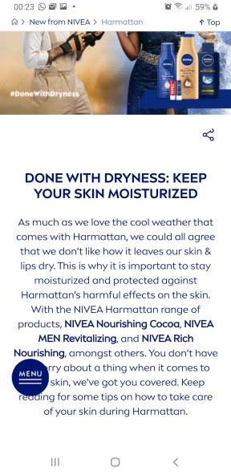 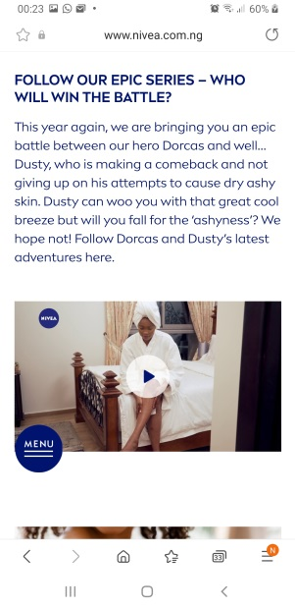

In a statement by Nivea introducing the campaign, it is clear that part of the essence of the campaign is the promotion of their new range of harmattan products – Nivea Nourishing Cocoa, Nivea Men Revitalizing and Nivea Rich Nourishing. In doing so, it takes advantage of Nigerians’ sensitivity to the harsh harmattan weather.



Nivea has over 23.5m followers on Facebook while [Nivea Nigeria](https://www.nivea.com.ng/?) on Instagram as [@nivea_ng](https://www.instagram.com/nivea_ng/) has over 125,000 followers. Each episode of the campaign series on their [YouTube channel](https://www.youtube.com/channel/UCV1LUA1r8N3haGSlRBGOFng) received an average 400,000+ views in addition to views on Instagram and Facebook. However, the campaign received mixed reactions from a cross-section of the Nigerian audience. Responses on the [Culture Intelligence](https://cultureintelligence.yafri.ca/) review of the campaign indicate praise for its brilliance in presenting a phenomenon as mundane as weather in a manner that is very relatable. It must also be noted that that each of episode was on average less than a minute thereby making it easy for viewers to snack on and each could pass as advert material in themselves. The campaign was also praised for its timing, considering that it was rolled out just before the beginning of the harmattan season.

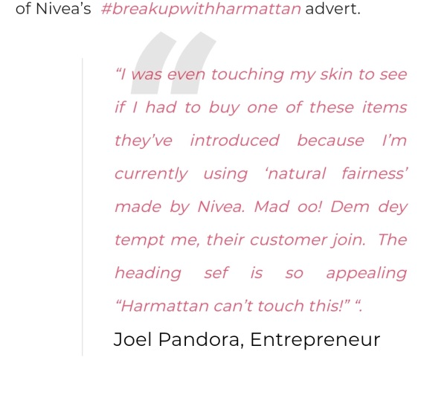 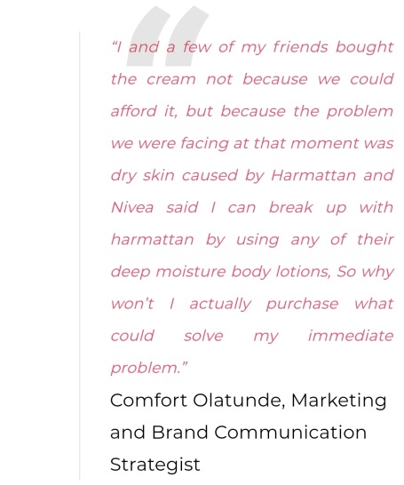

On the other hand, the campaign was criticized for its persistent recourse to mundane stereotypes. In this sense, the campaign followed same pattern of situating the message within a romantic relationship between a man and a woman. Some Twitter users also lamented the its weak storyline alluding to sudden cuts to the climax in the drama.

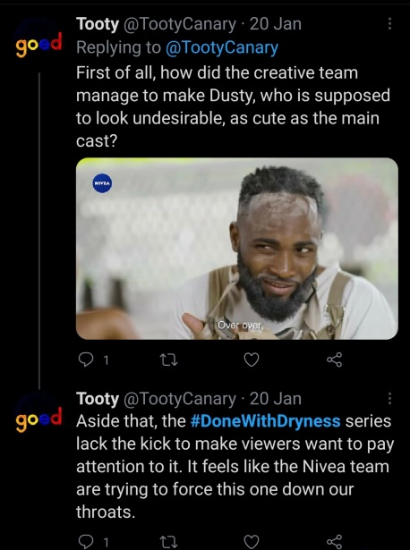 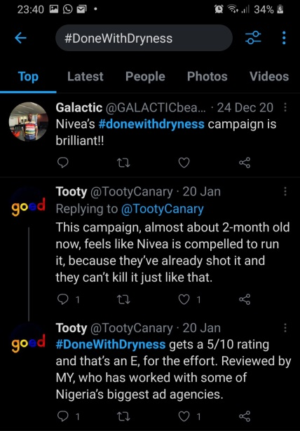

The hashtag approach to the campaign which was deployed by way of requesting social media users to [post a picture of themselves holding up a Nivea product](https://www.instagram.com/p/CH8zbvGFvpe/) and including any of the #BreakupWithHarmattan or #DoneWithDryness hashtags was not as viral. Both hashtags pooled less than 600 posts cumulatively.

